H.T No
Regulations:
A20

Sreenidhi Institute of Science and Technology
(An Autonomous Institution)
Code No: 8HC13 Date: 19-Feb-2025 (FN)

B.Tech I-Year II- Semester External Examination, February-2025 (Supplementary)
DIFFERENTIAL CALCULUS AND NUMERICAL METHODS (CSE, CS, AI&ML, DS, IOT, IT and ECM)

Time: 3 Hours Max.Marks:70

Note: a) No additional answer sheets will be provided.
b) All sub-parts of a question must be answered at one place only, otherwise it will not be valued.
c) Missing data can be assumed suitably.
Bloom's Cognitive Levels of Learning (BCLL)

Remember | L1 | Apply | L3 | Evaluate | L5
Understand | L2 | Analyze | L4 | Create | L6

Part - A Max.Marks:20

Answer all QUESTIONS.

 |  | BCLL | CO(s) | Marks
1 | Solve 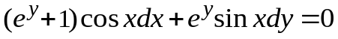 | L2 | CO1 | [2M]
2 | Solve | L2 | CO2 | [2M]
3 | If 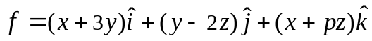 is solenoidal then find 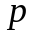 | L2 | CO3 | [2M]
4 | Write the formula to find root of an equation using Regula Falsi Method | L1 | CO4 | [2M]
5 | Prove that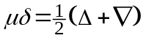 | L1 | CO5 | [2M]
6 | State Runge-Kutta 4th order formula to solve differential equation. | L2 | CO6 | [2M]
7 | If is exact then find the values of 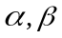 | L2 | CO1 | [2M]
8 | Find unit vector normal to the surface at the point (2,2,3) | L2 | CO3 | [2M]
9 | Find the first approximation to the solution of 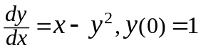 using Picard’s method | L1 | CO5 | [2M]
10 | Solve | L2 | CO2 | [2M]

Part – B Max.Marks:50
ANSWER ANY FIVE QUESTIONS. EACH QUESTION CARRIES 10 MARKS.

 |  |  | BCLL | CO(s) | Marks
11. | a) | Solve 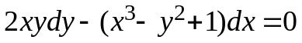 | L3 | CO1 | [5M]
 | b) | If the air is maintained at 20°C and the temperature of the body cools from 100°C to 80°C in 10 minutes, find the temperature of the body after 20 minutes | L3 | CO1 | [5M]
12. | a) | Solve | L3 | CO2 | [5M]
 | b) | Solve the differential equation:  ( | L3 | CO2 | [5M]
13. | a) | Find three positive numbers whose sum is 100 and whose product is maximum | L3 | CO3 | [5M]
 | b) | If 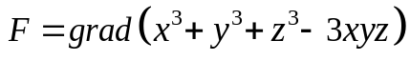 find 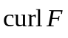 | L3 | CO3 | [5M]
14. | a) | Find by Newton –Raphson method ,the real root of equation 3x = cosx + 1 | L3 | CO4 | [5M]
 | b) | Evaluate , taking h = 0.1 using  (i) Trapezoidal rule  (ii) Simpson’s rule | L3 | CO4 | [5M]
15. |  | The population of a certain town in decennial census was given below. Estimate the population of the town for the years (i) 1925 and (ii) 1955 | L3 | CO5 | [10M]
  Year | 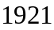 | 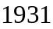 | 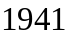 | 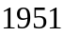 | 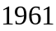
  Population  (inThousands) | 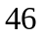 | 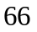 | 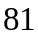 | 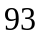 | 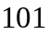
16. | a) | Solve = 1-y , y(0) = 0 using Euler’s method.  Find y at x = 0.1 | L3 | CO6 | [5M]
 | b) | Find y(1.1) using Runge-Kutta method of order four for the initial value problem, = x² + y² , y(1) = 0 | L3 | CO6 | [5M]
17. | a) | Solve 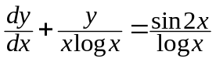 | L3 | CO1 | [4M]
 | b) | Solve 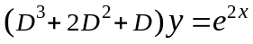 | L3 | CO2 | [3M]
 | c) | If 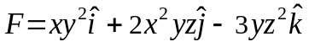find 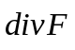at 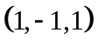 | L3 | CO3 | [3M]
18. | a) | Evaluate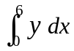 by Trapezoidal rule given that 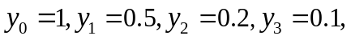 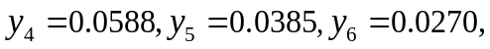and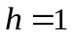 | L3 | CO4 | [4M]
 | b) | Evaluate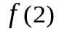using Lagrange’s interpolation formula from the following data | L3 | CO5 | [3M]
   | 0 | 1 | 3 | 4
  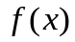 | 5 | 6 | 50 | 105
 | c) | Solve 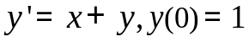by Taylor’s series method up to the term containing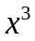 | L3 | CO6 | [3M]

-- 00 -- 00 –

